1.7 Centers of Gravity

General Idea
Suppose we have a flat plate (called a lamina) of some material with uniform density which occupies a region of the xy-plane. A picture of a possible “plate” (we will assume plates are two dimensional) is below:
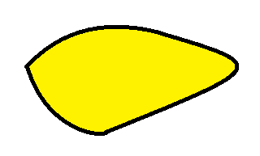
Intuitively speaking the center of mass/gravity of the plate (also called the centroid) is the point at which the plate will balance perfectly.

If a plate with uniform density, , occupies the region in the $xy$-plane bounded by a curve given by where and the x-axis, then the mass of the plate is given by provided that is a continuous nonnegative function.

Note: The formula for mass should remind you of density times volume. Only in this case we use density times area since a lamina is two dimensional.

Formula (Moments and Center of Gravity/Mass): Suppose is a continuous nonnegative function. If a plate with uniform density, , occupies the region in the xy-plane bounded by the curve given by where and the x-axis, then:
- The moment of the plate about the y-axis is .
- The moment of the plate about the x-axis is .
- The center of gravity (centroid) of the plate is where and where A is the area of the region that the plate occupies.

Note: As we can see in the above formulas the center of gravity does not depend on the density when the density is uniform. In Calculus 3 you will see (as you would probably expect) that the center of gravity does depend on the density when the density is not uniform.

Note: The book present reasoning behind these formulas at the start of the section. I have decided to omit this from the notes, since you will return to this problem (in much more generality) in Calculus 3.

Note: Intuitively speaking we can we can view (as the notation suggests) and as the average x and y coordinates respectively in the region which the plate occupies.

Example 1: Find the center of gravity of the plate with uniform density which occupies the region: where r is some positive real number.

A picture of the region is:

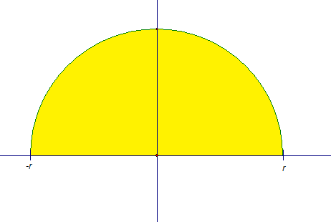
Using our knowledge of area of a circle we have the area of the region is . Now, by the above formulas and
Thus, the center of gravity (the centroid) is .

Question: Does this answer make sense intuitively?

Example 2:
- Sketch the region, R, in the first quadrant bounded by the curves , , and .

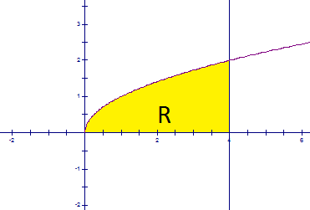

- Suppose a plate with uniform density occupies the region R. Find the exact center of gravity of the plate.

First, we calculate the area of the plate. It is . By the given formulas and

Thus, the center of gravity (the centroid) is .

